
RATES FOR COURSE FEES AND OTHER SERVICES EFFECTIVE 1ST JULY, 2025
Course fees | RATE | USD
Bar Course-Ugandan and EA Applicants | 6,000,000
Applicants outside Uganda and EA |  | 3000
Diploma in Law | 2,500,000 | 2000
Diploma in Human Rights | 2,500,000 | 2000
Administrative Officers Law Course | 1,100,000 | 650
Tailor Made short courses | 2,000,000
Other services
Application fees  -Bar Course  -Diploma in Law  -Diploma in human Rights  Administrative Officers Law Course | 200,000  100,000  100,000  100,000
Certificate | 100,000
Transcript | 100,000
Certification per copy | 10,000
Replacement of transcript | 200,000
Urgent replacement of transcript | 400,000
Graduation Fees Bar Course | 200,000
Graduation Fees Diploma in Law and Human Rights | 200,000
Graduation Fees Short Courses | 100,000
Special/ supplementary  Bar Course per paper  Diploma in Law-Per paper | 300,000  100,000
Repeating failed subject- Compulsory subject group-A  -Compulsory subject group-B  -Compulsory subject group- C | 2,000,000  1,500,000  1,500,000
Late Registration for Bar Course and Diploma courses.  After 14 days of the deadline for payments of fees  after 28 days of the deadline for payment fees) | 50,000  200,000
Verification-Per paper | 100,000
Appeal | 100,000
Replacement of Identity Card | 25,000
Canteen-Per month | 2,000,000
Auditorium - (General public)  - (LDC staff) | 6,000,000  4,000,000
Main Hall - (General public)  - (LDC staff) | 3,000,000  2,000,000
Binaisa Garden - (General public)  - ( LDC staff) | 2,500,000  1,500,000
Nomination fee | 200,000
Library Use Fee-External Member -Daily | 5,000
Library Use Fee- External member- Per Year | 200,000
Library Use Fee- Institution -Per Year | 500,000
Verification of academic documents- per document | 20,000

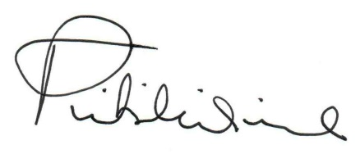

Dr. Pamela Tibihikirra- Kalyegira
DIRECTOR

